**DAILY ONLINE ACTIVITIES SUMMARY**

|  |  |  |  |  |  |  |  |  |
| --- | --- | --- | --- | --- | --- | --- | --- | --- |
| **Date:** | **12/06/2020** | | | | | **Name:** | **Soundarya R** | |
| **Sem & Sec** | **6th & B** | | | | | **USN:** | **4al17cs096** | |
| **Online Test Summary** | | | | | | | | |
| **Subject** | |  | | | | | | |
| **Max. Marks** | |  | | **Score** | | |  | |
| **Certification Course Summary** | | | | | | | | |
| **Course** | **Compute, Organization &IAM** | | | | | | | |
| **Certificate Provider** | | | **Great Learning Academy** | | **Duration** | | | **10 hours** |
| **Coding Challenges** | | | | | | | | |
| **Problem Statement:2programs** | | | | | | | | |
| **Status:solved** | | | | | | | | |
| **Uploaded the report in Github** | | | | | **yes** | | | |
| **If yes Repository name** | | | | | **http://github.com/ashu102/Daily-Activities** | | | |
| **Uploaded the report in slack** | | | | | **yes** | | | |

Certification Course Details:

Coding Challenges Details:

1. Write a java program to find maximum width of a binary tree

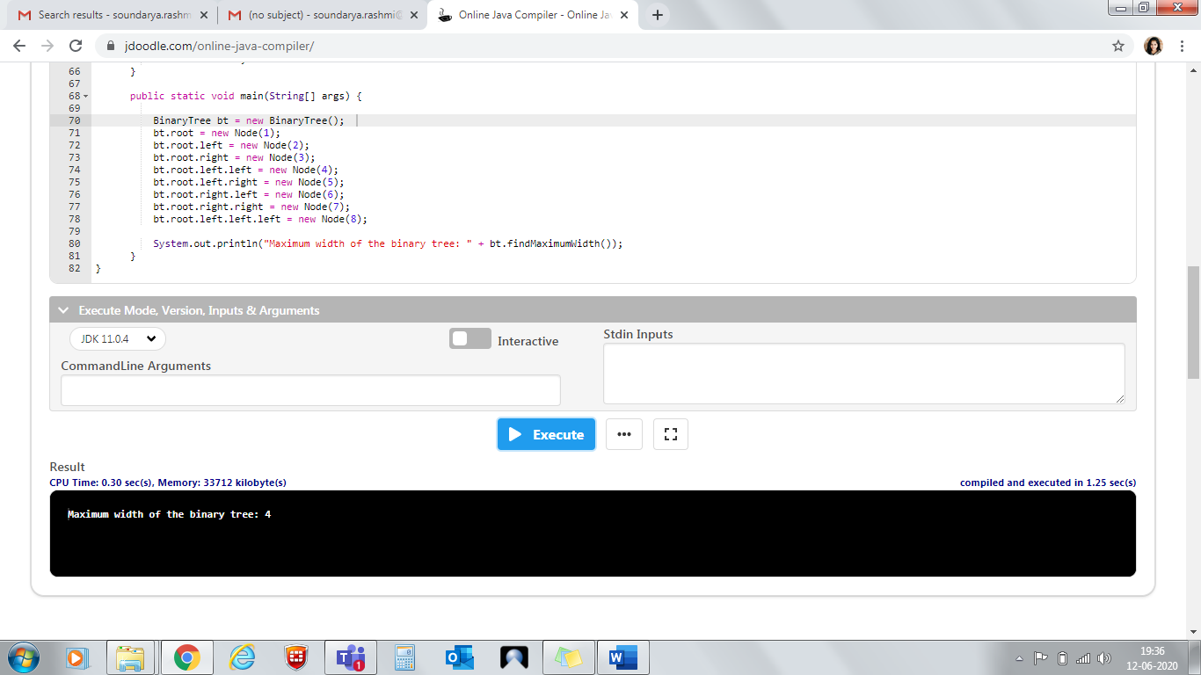

2. **Python program to Count the Number of Vowels Present in a String using Sets Step1: Get a string Step2: find the no of occurrence of all vowels in the string using data structure set**

